Design Document: Attack–Defence Tree for an IoT-Based Smart Home System of Systems
Group name : Shamshir
- sultan alkaabi
- Franz Stephan
- Suhail Almaskari
- younis alhussaini
2026

1. Introduction and Case Study Selection
This project models the security risks of an Internet of Things (IoT)–based smart home using an Attack–Defence Tree (AD-Tree). A smart home represents a clear System of Systems (SoS), comprising multiple autonomous yet interoperating subsystems, including sensors, actuators, gateways, mobile interfaces, and cloud services. In accordance with the SoS characteristics defined by Boardman and Sauser, these systems demonstrate autonomy, belonging, connectivity, diversity, and emergent behaviour. While each component operates independently, their interactions enable higher-level functionality such as automation, safety, and energy management.
Smart homes rely heavily on continuous machine-to-machine (M2M) and peer-to-peer (P2P) communication, which increases exposure to cyber threats. Academic research and industry standards consistently indicate that IoT-based cyber-physical systems (CPS) are vulnerable to attacks that threaten the Confidentiality, Integrity, and Availability (CIA) triad, particularly where centralised coordination mechanisms are employed. These characteristics make the smart home an appropriate and realistic case study for AD-Tree-based security modelling.

2. Identification of Security Vulnerabilities
Potential vulnerabilities were identified through a review of peer-reviewed academic literature and recognised IoT security standards. Vulnerabilities are categorised across three layers: client devices, hub/controller, and the overall system.
At the client (IoT device) level, vulnerabilities primarily arise from limited computational resources and constrained security capabilities. Common issues include weak or default authentication credentials, susceptibility to physical tampering and device impersonation, and exposure to denial-of-sleep attacks that exhaust battery and processing resources. These vulnerabilities are widely documented in CPS and IoT literature and are reinforced by standards that identify inadequate authentication and device lifecycle management as persistent risks.
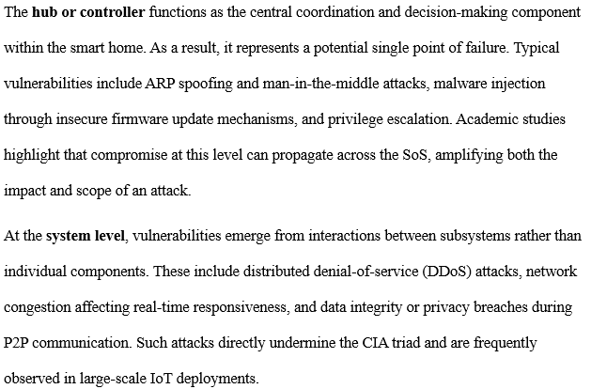

3. Attack–Defence Tree Modelling
An Attack–Defence Tree was constructed using Luxembourg ADTree software to model the identified vulnerabilities. The root attack node represents the attacker’s primary objective: “Compromise the Smart Home System of Systems.” This node is refined using OR-refinement, reflecting the fact that compromise of any major subsystem can result in overall system compromise.
Three primary attack branches are defined:
- Compromise IoT client devices
- Compromise the hub/controller
- Compromise the networked SoS infrastructure
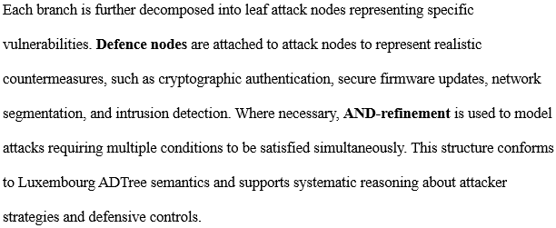Attack
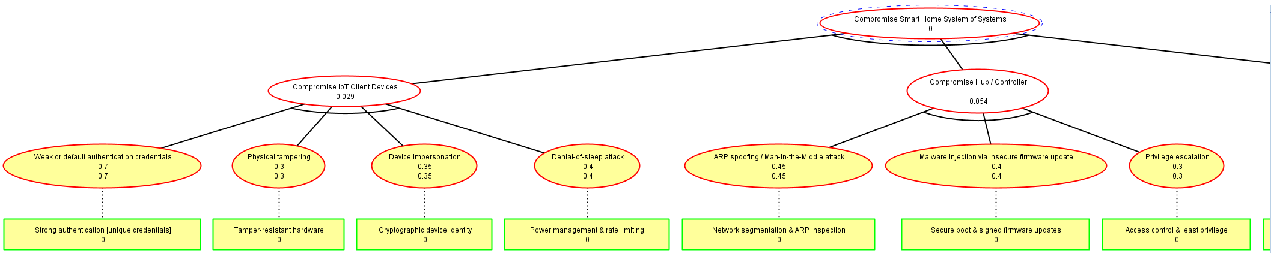
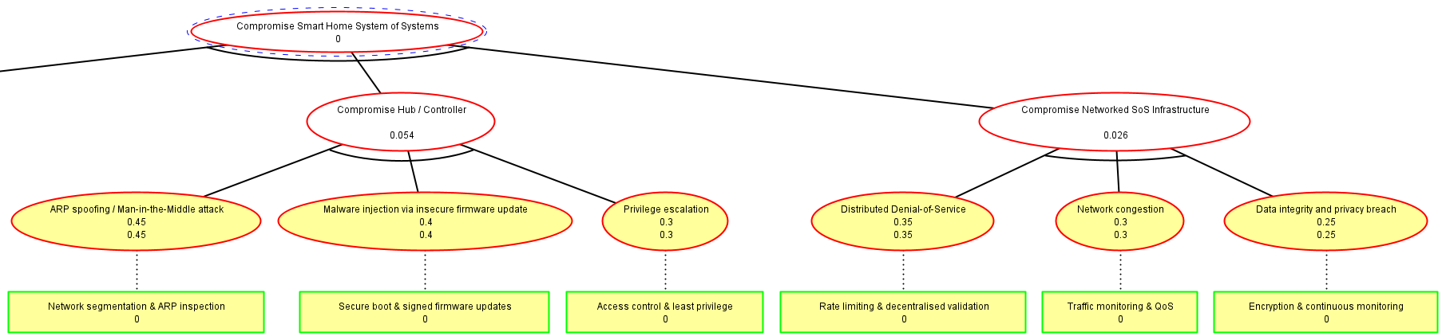

Defence
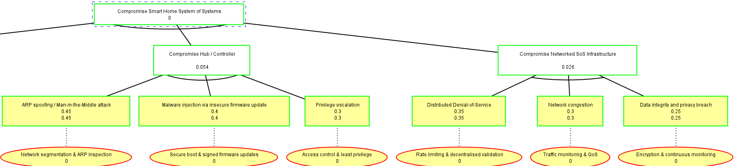
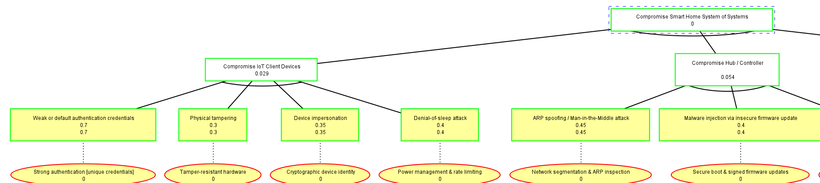
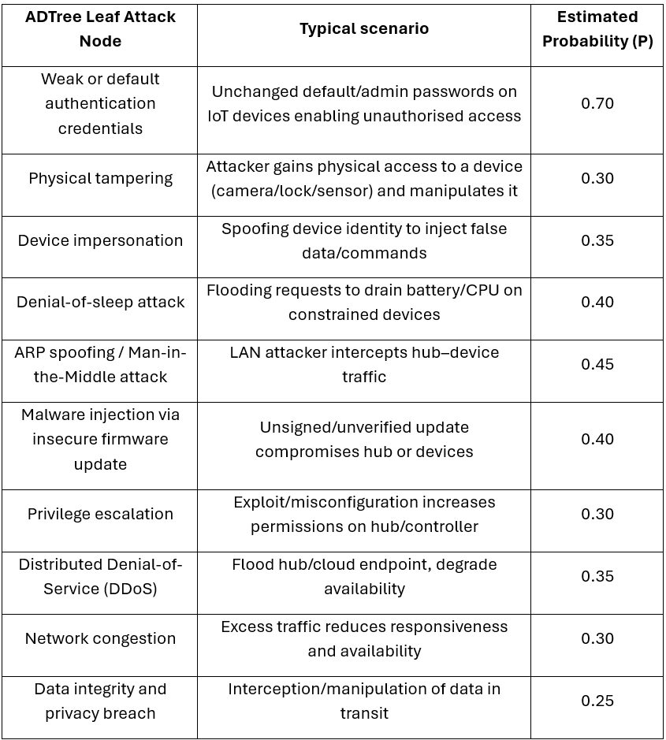

4. Quantitative Evaluation Domain
To enable quantitative analysis, a probability-based risk domain aligned with the CIA triad was selected. Each leaf attack node is assigned a likelihood value in the range [0,1], representing the estimated probability of successful exploitation. Risk is computed as a function of likelihood and impact on confidentiality, integrity, and availability.
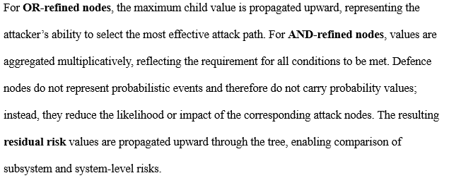

5. Mitigation Strategies
Mitigation strategies are derived directly from the AD-Tree and mapped explicitly to identified attack paths.
At the device level, mitigations include strong cryptographic identity management, secure boot mechanisms, tamper-resistant hardware, and lightweight authentication protocols suitable for constrained devices.
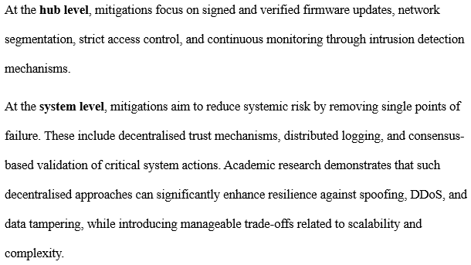Table 1: Attack–Defence Traceability
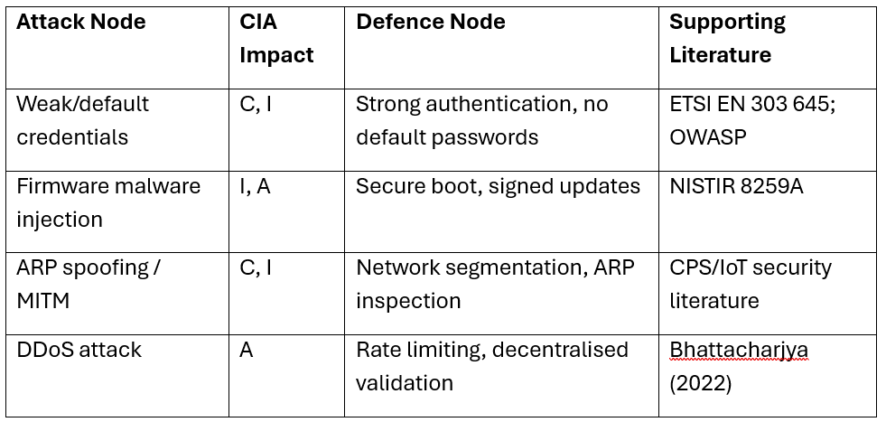

6. Conclusion and learning Outcomes
This design document demonstrates the effective use of an Attack–Defence Tree to analyse security risks in an IoT-based smart home System of Systems. By identifying vulnerabilities across device, hub, and system layers, applying Luxembourg ADTree modelling, selecting a justified quantitative domain, and deriving targeted mitigations, the work provides a structured approach to CPS security analysis. The model supports both qualitative reasoning and quantitative evaluation, addressing key challenges in secure distributed system design.
The assignment fulfils the learning outcomes by:
- Critically analysing operating system and network risks in distributed CPS environments
- Evaluating secure architectural adaptations for IoT-based systems
- Demonstrating structured, team-based security modelling aligned with professional practice

References
Bhattacharjya, A. (2022). A holistic study on the use of blockchain technology in CPS and IoT architectures maintaining the CIA triad. International Journal of Applied Mathematics and Computer Science, 32(3), 403–413. https://doi.org/10.34768/amcs-2022-0029
ETSI. EN 303 645: Cyber Security for Consumer Internet of Things. https://www.etsi.org/deliver/etsi_en/303600_303699/303645/03.01.03_60/en_303645v030103p.pdf
NIST. NISTIR 8259A: IoT Device Cybersecurity Capability Core Baseline. https://nvlpubs.nist.gov/nistpubs/ir/2020/NIST.IR.8259a.pdf
OWASP Foundation. OWASP Internet of Things Project. https://owasp.org/www-project-internet-of-things/

